PWA Video 13 The install Banner

<https://www.youtube.com/watch?v=9whdWJ4q7jE>

Criteria have been met so now google will show the banner to add to home page at the top – android emulator

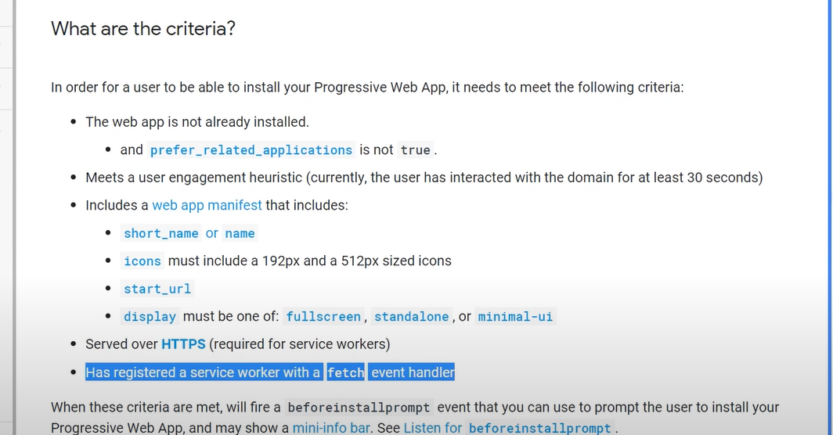

The emulator is not showing local host or https so need to do some trickery with the chrome dev tools

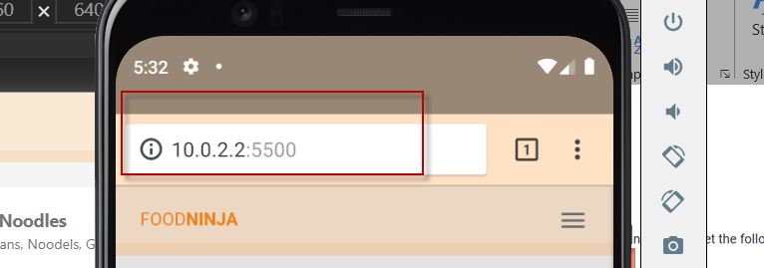

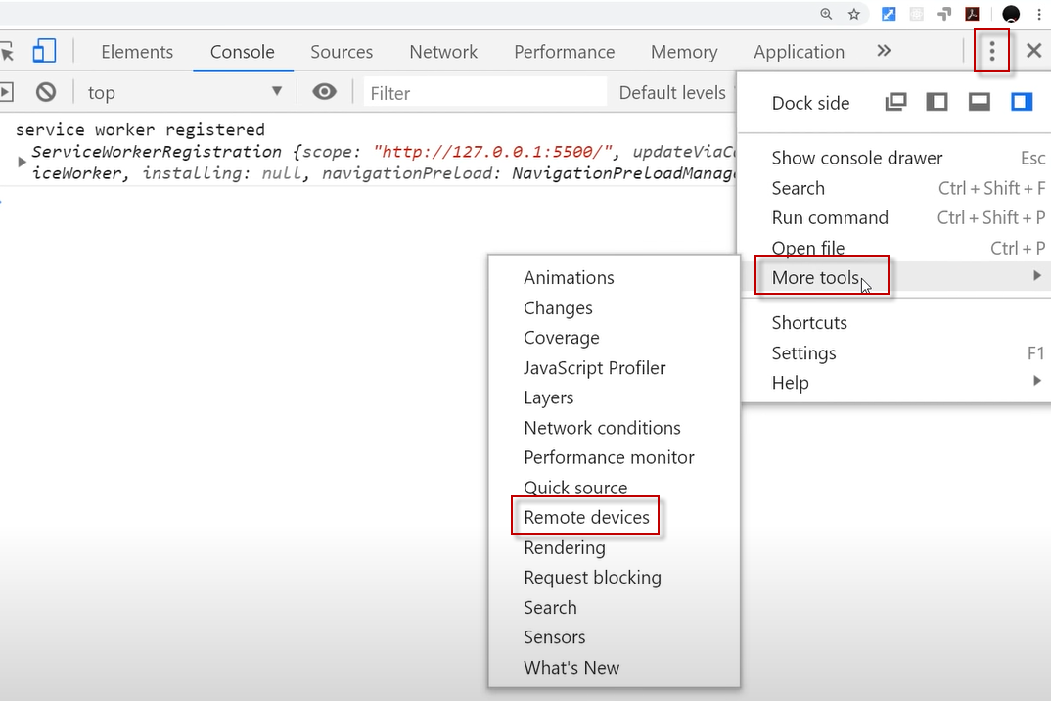

Have to use a different tool now

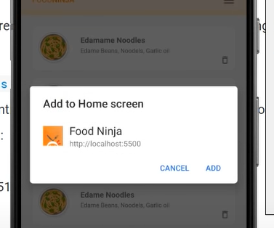

This can be a bit buggy in the dev tools